**WEB PLATFORM**

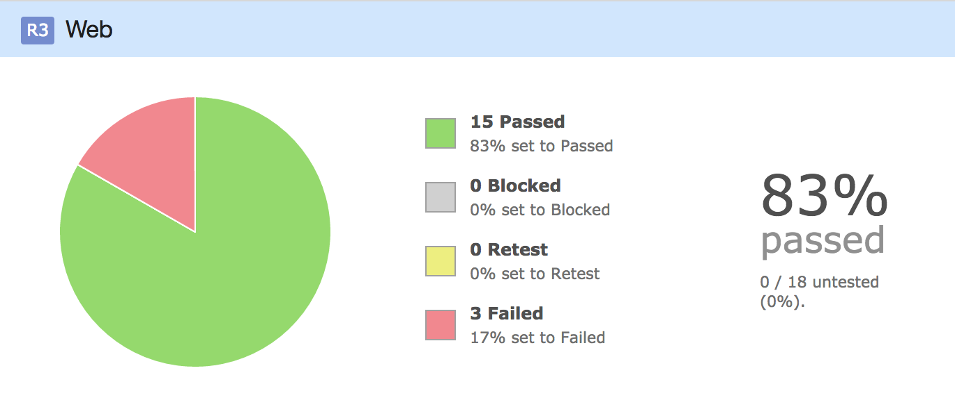

* Test Cases Planned: 18
* Test Case Implemented: 18
* Test Cases Executed: 18
* Test Cases Passed: 15
* Test Cases Failed: 3

***UPLOAD COMPONENT (WEB)***

**Test Case #1:** Testing Upload of images using upload button.

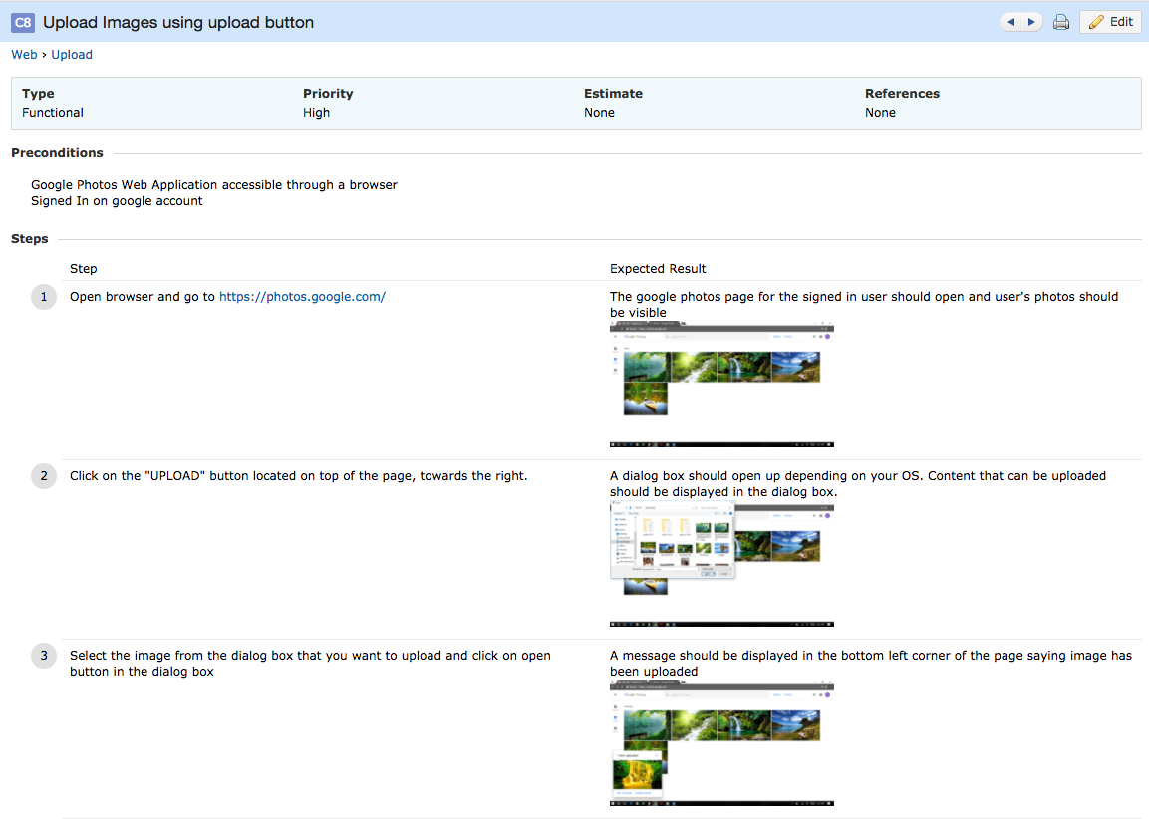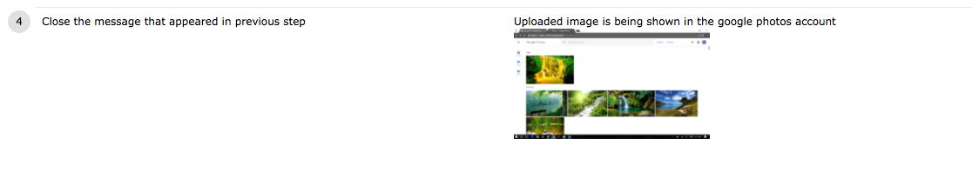

**Test Case #2:** Testing Upload of invalid files using upload button.

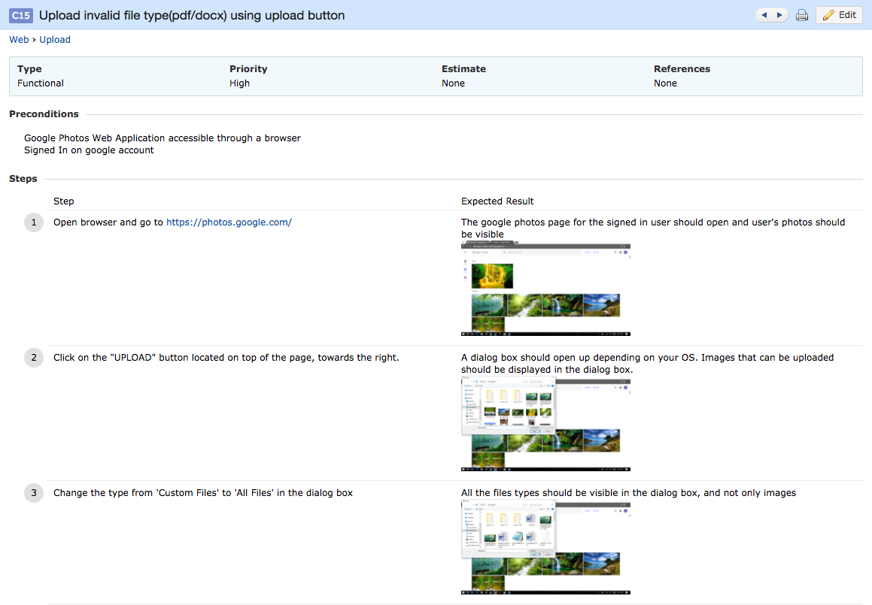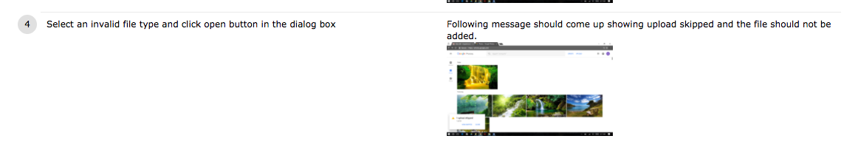

**Test Case #3:** Testing Upload of videos using upload button.

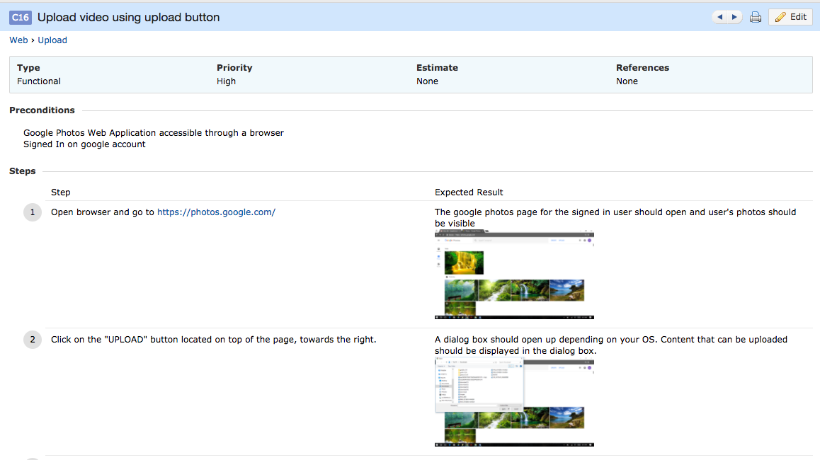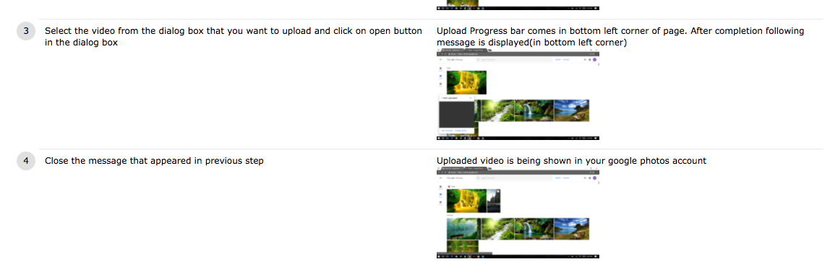

**Test Case #4:** Testing Upload of image using Drag and drop feature.

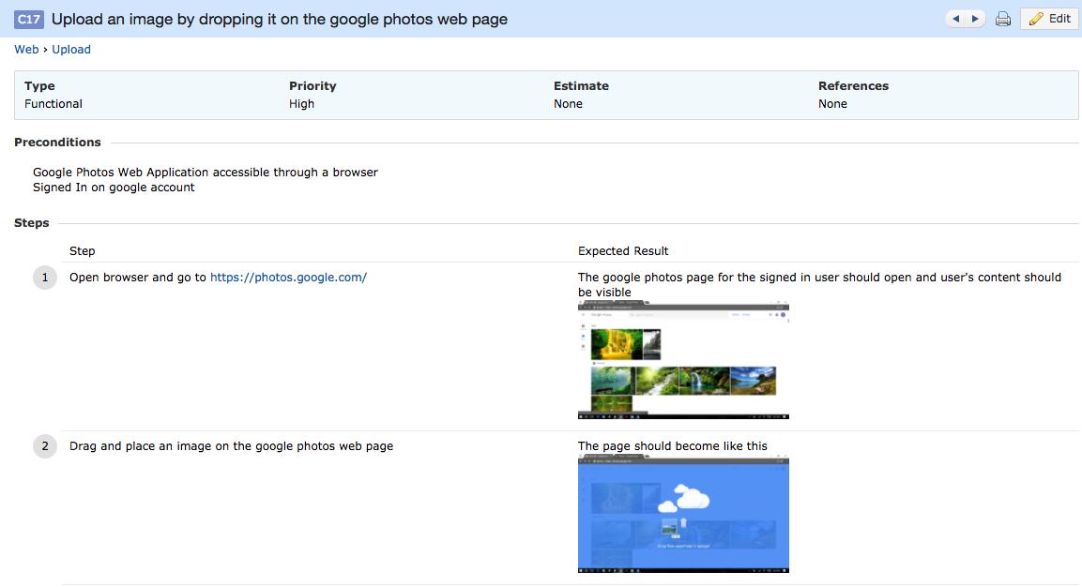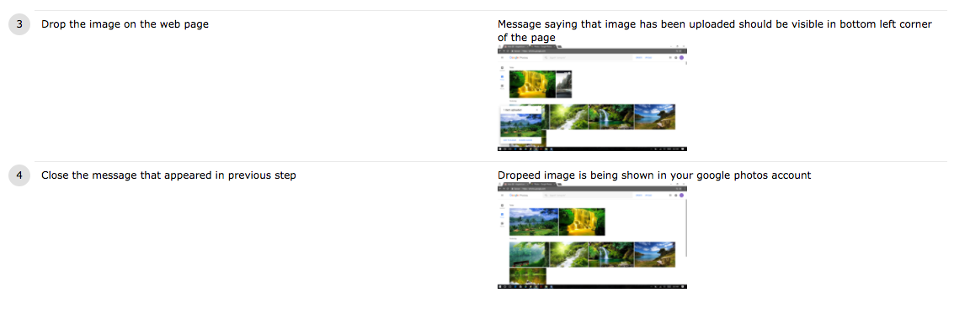

**Test Case #5:** Testing Upload of invalid files using Drag and drop feature.

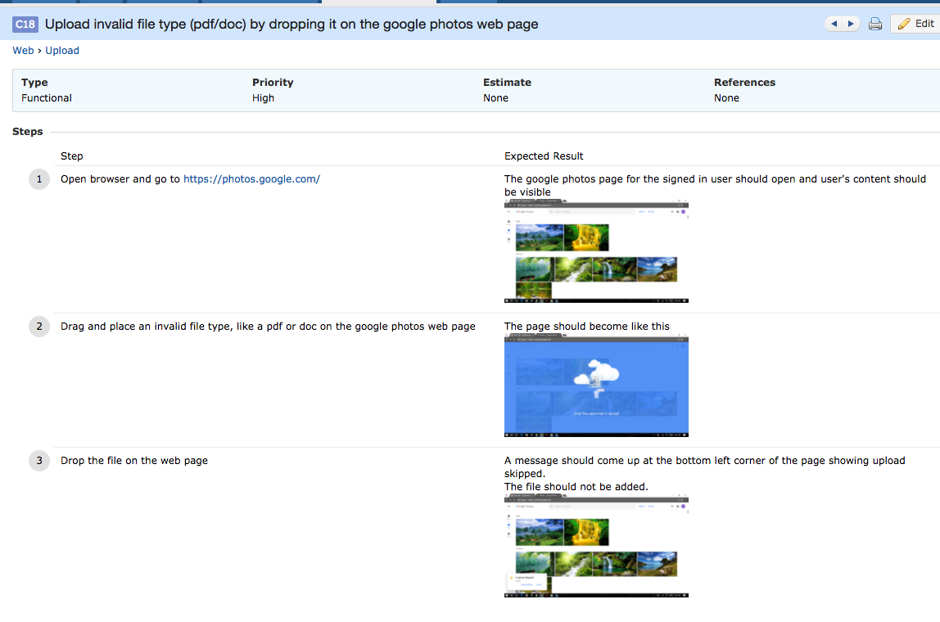

***ALBUM COMPONENT (WEB)***

**Test Case #1:** Testing Creation of Album.

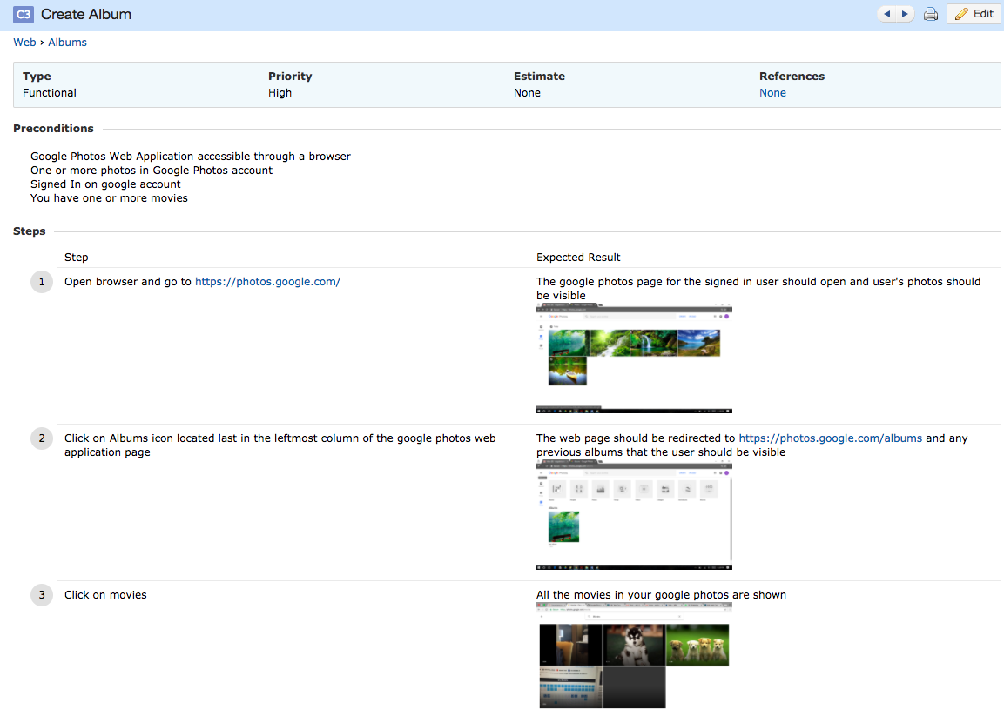

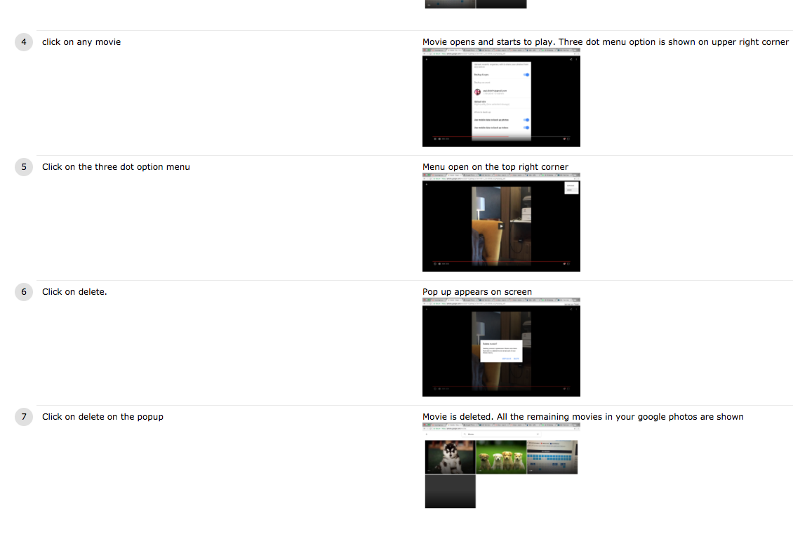

**Test Case #2:** Testing Album content after deletion of media.

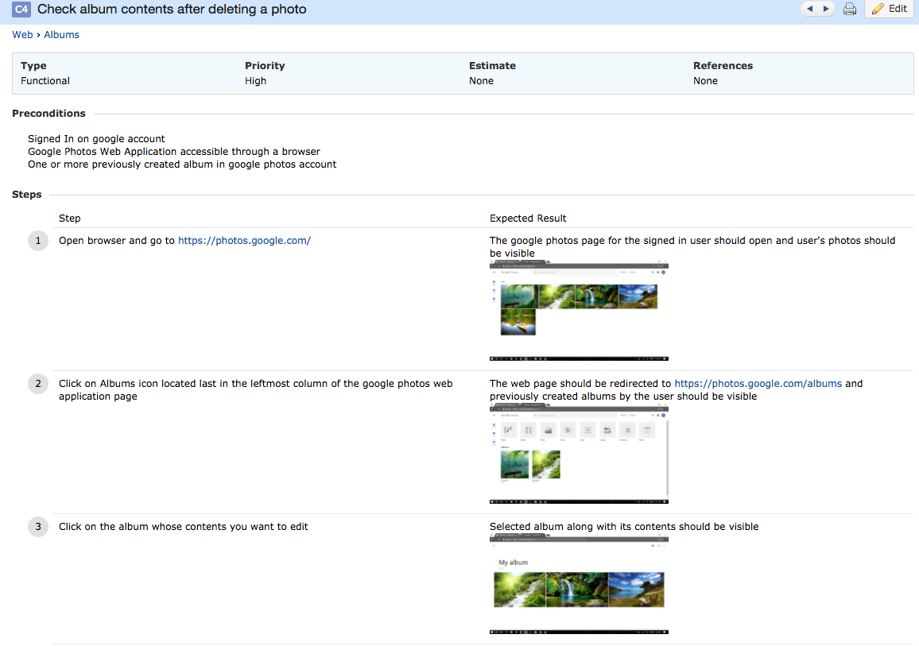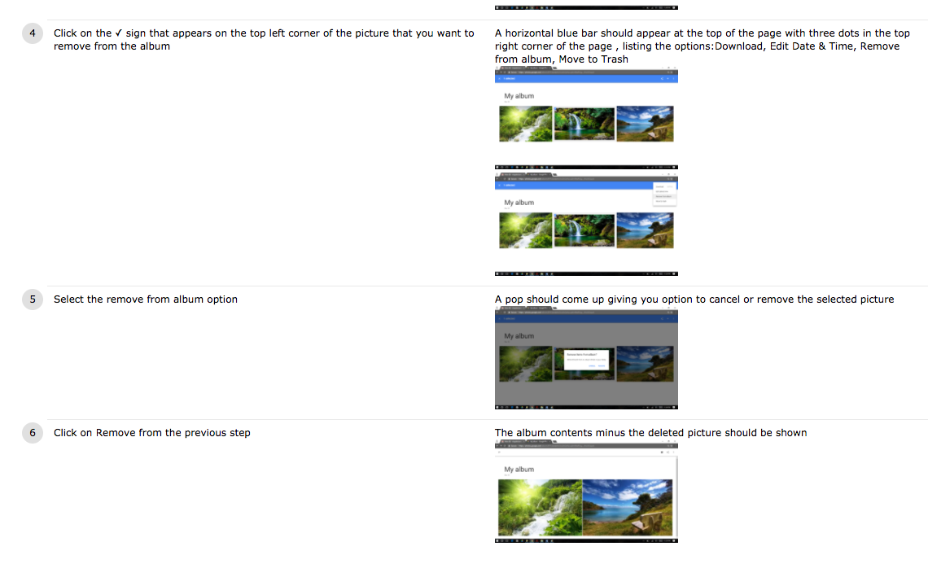

**Test Case #3:** Testing Setting cover for Album.

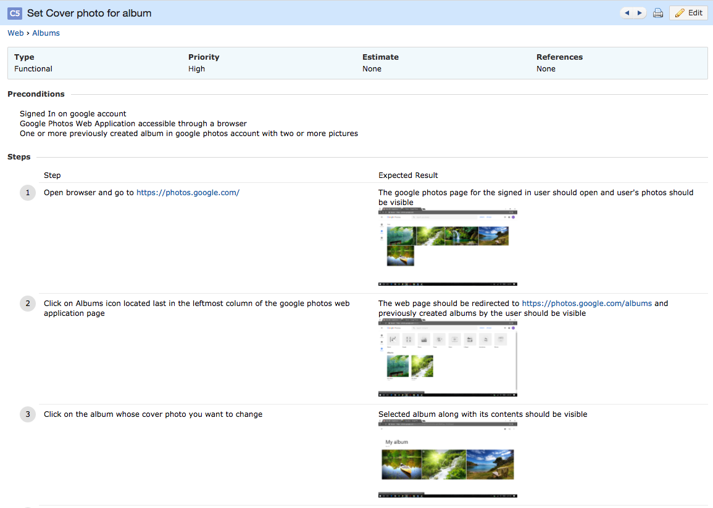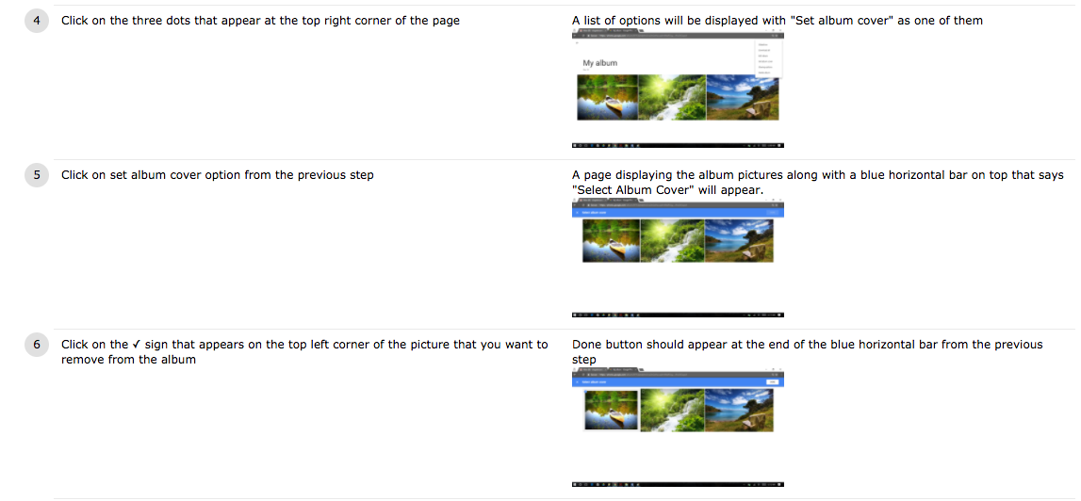

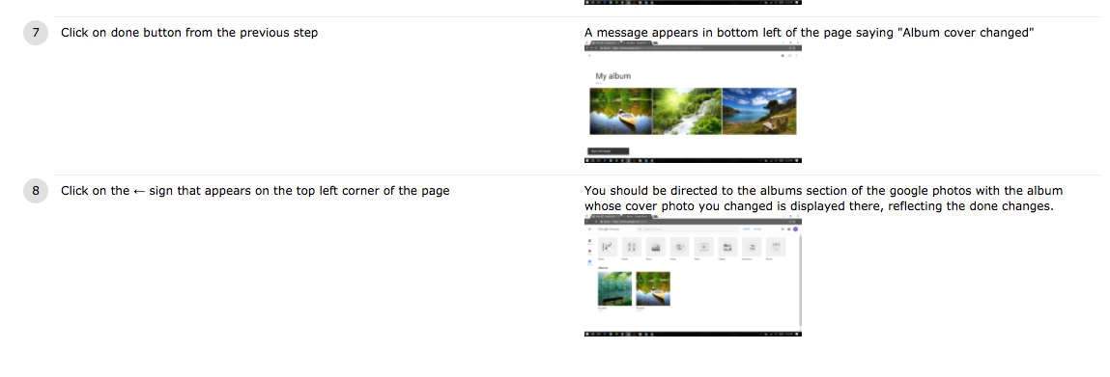

**Test Case #4:** Testing Deletion of Album when all photos deleted.

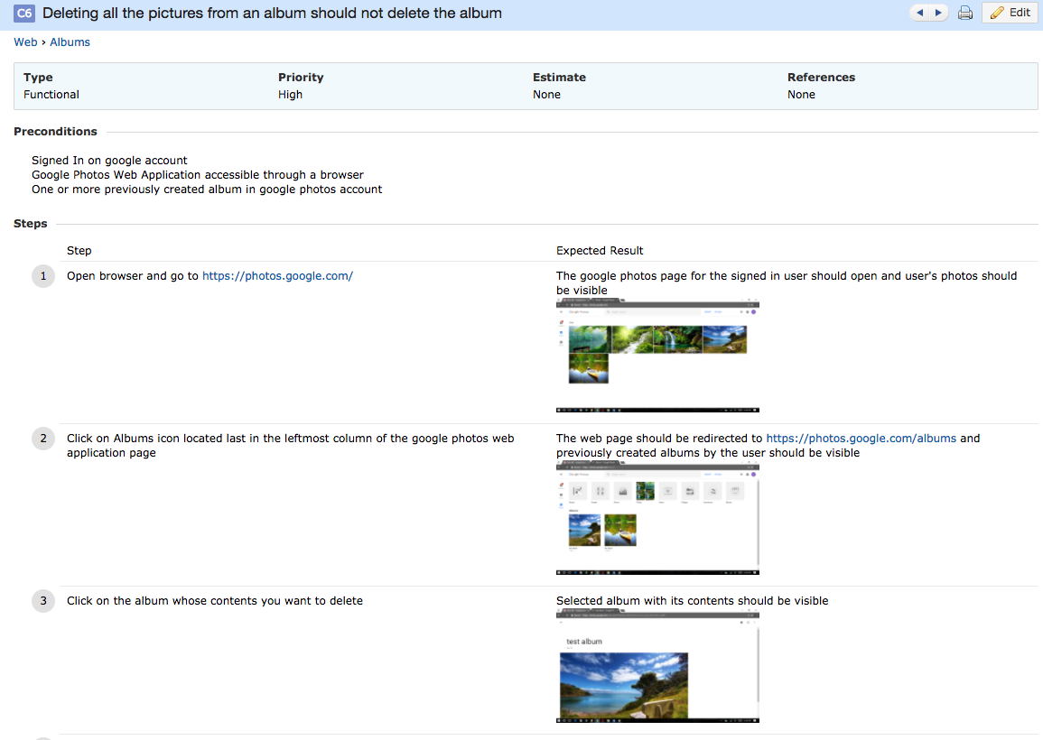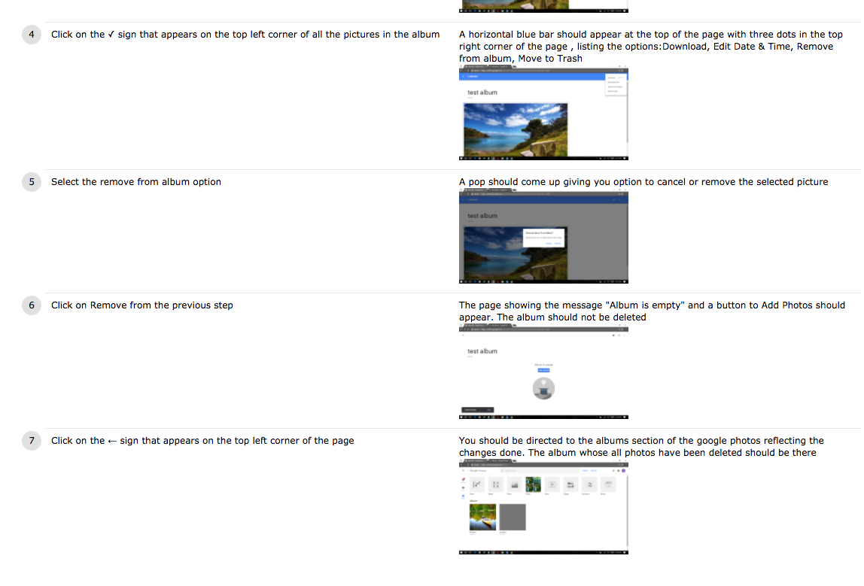

**Test Case #5:** Testing Addition of location to Album.

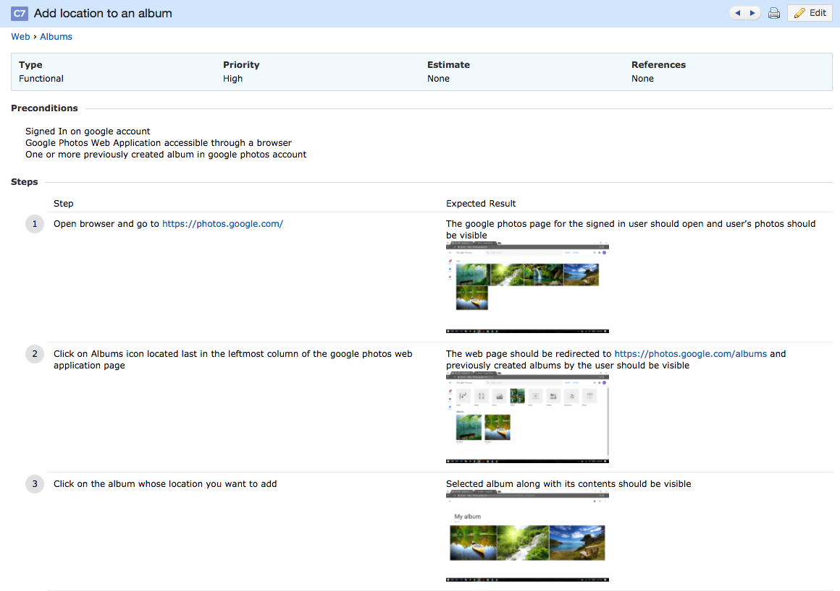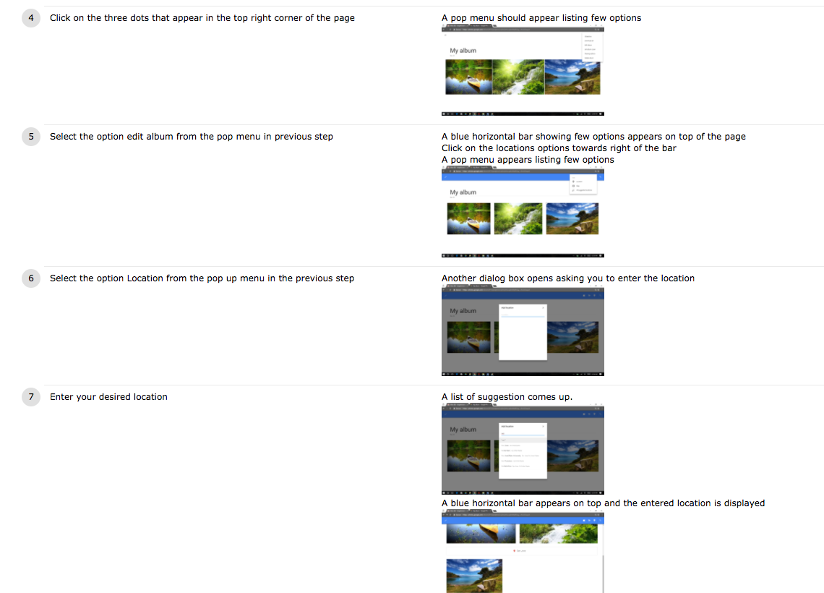

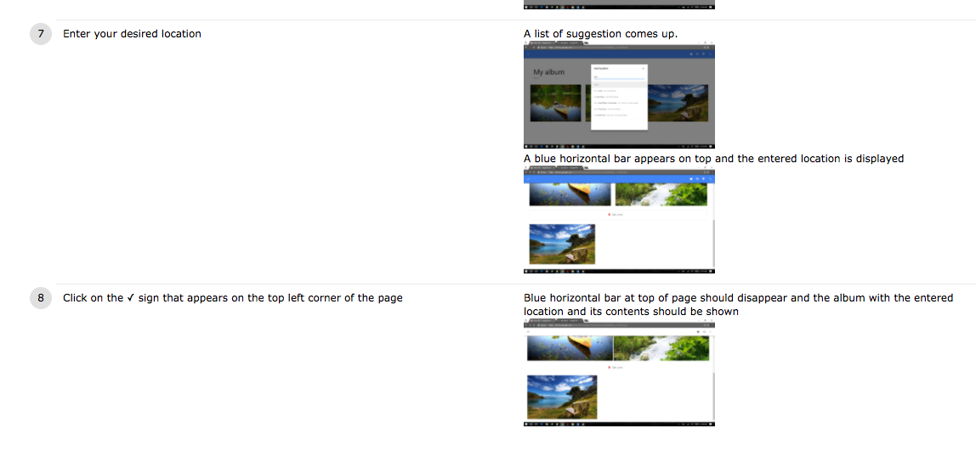

**Test Case #6:** Testing Deletion of a Movie.

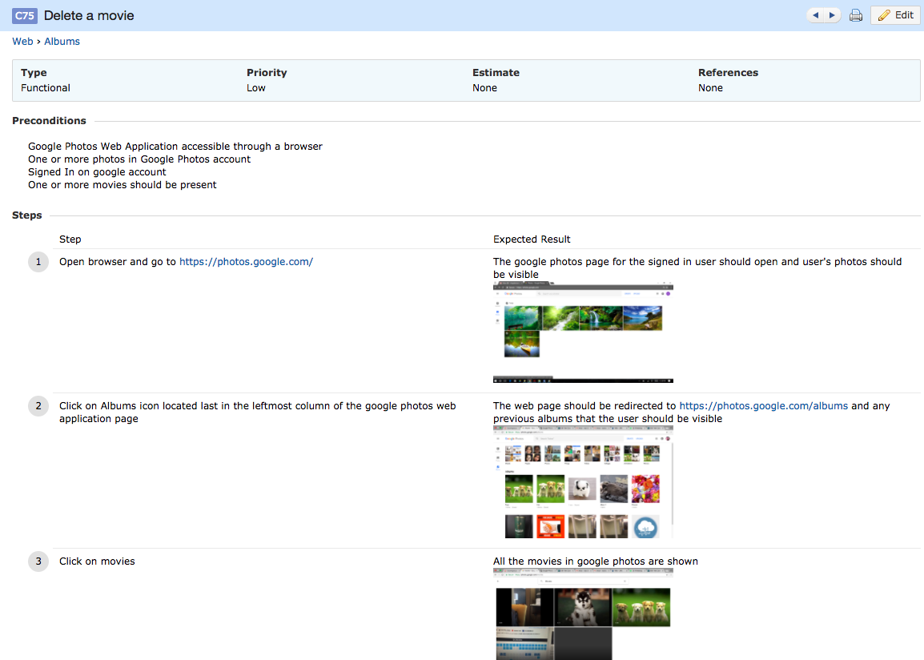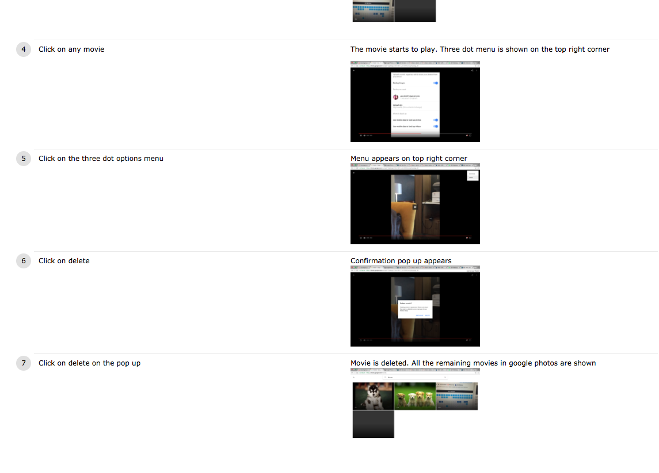

**Test Case #7:** Testing Desktop Uploader Link Navigation.

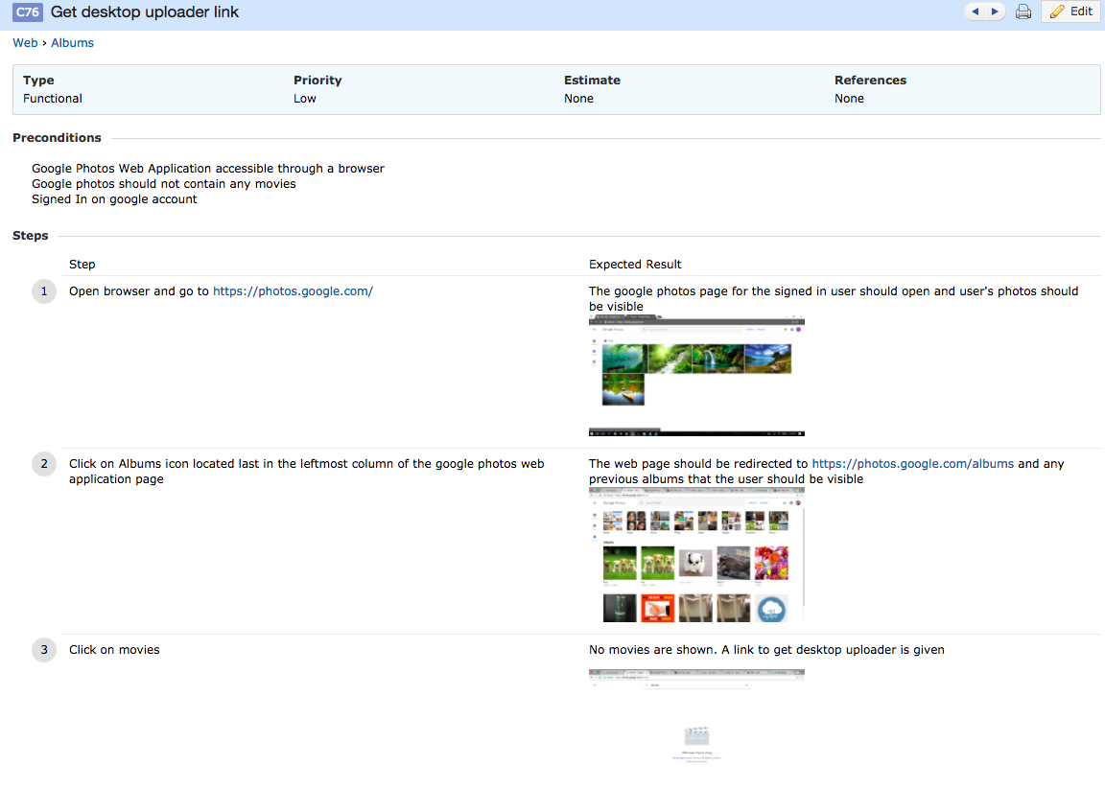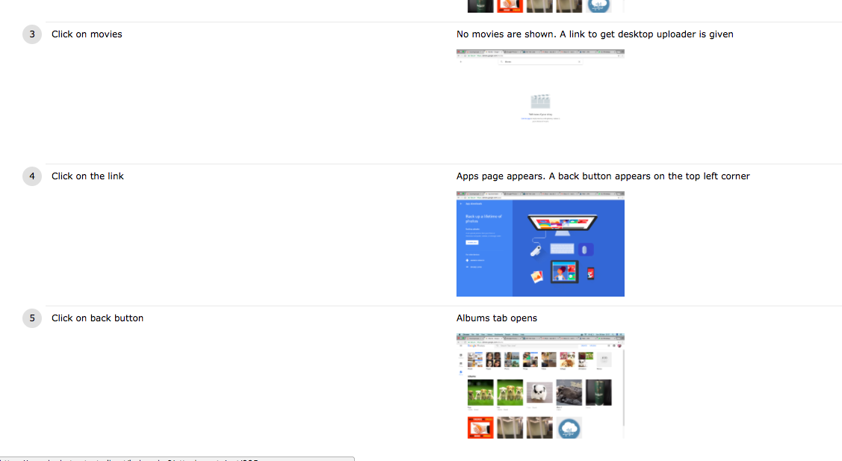

***SHARE COMPONENT (WEB)***

**Test Case #1:** Testing Sharing of Album.

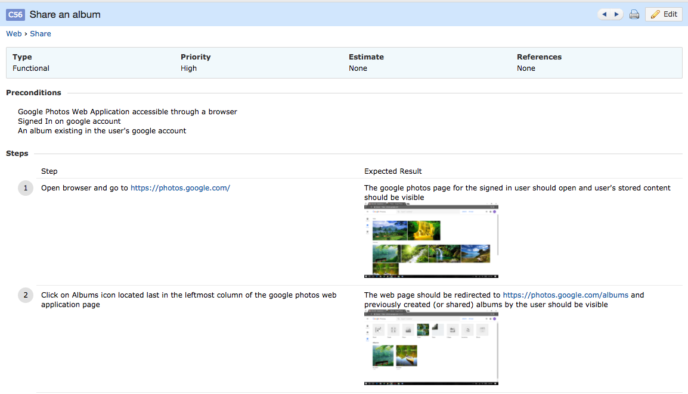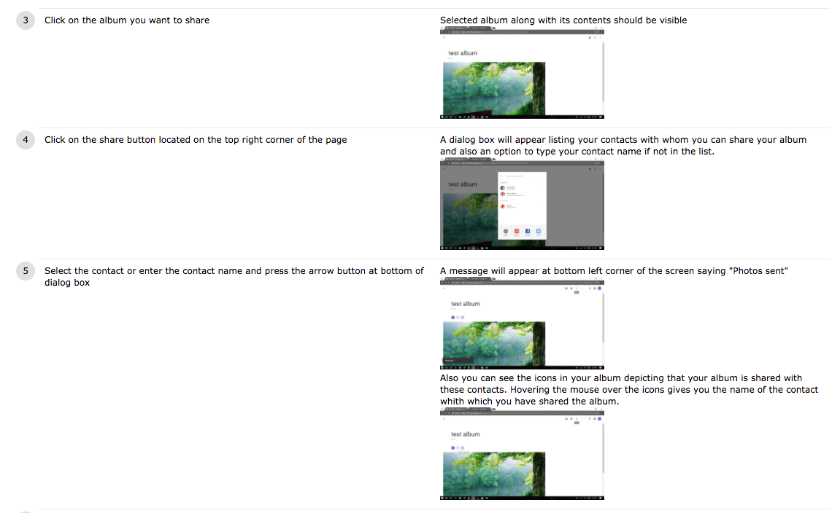

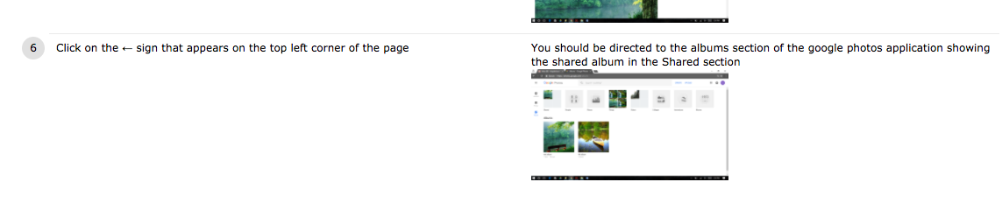

**Test Case #2:** Testing Comments functionality on Shared Album.

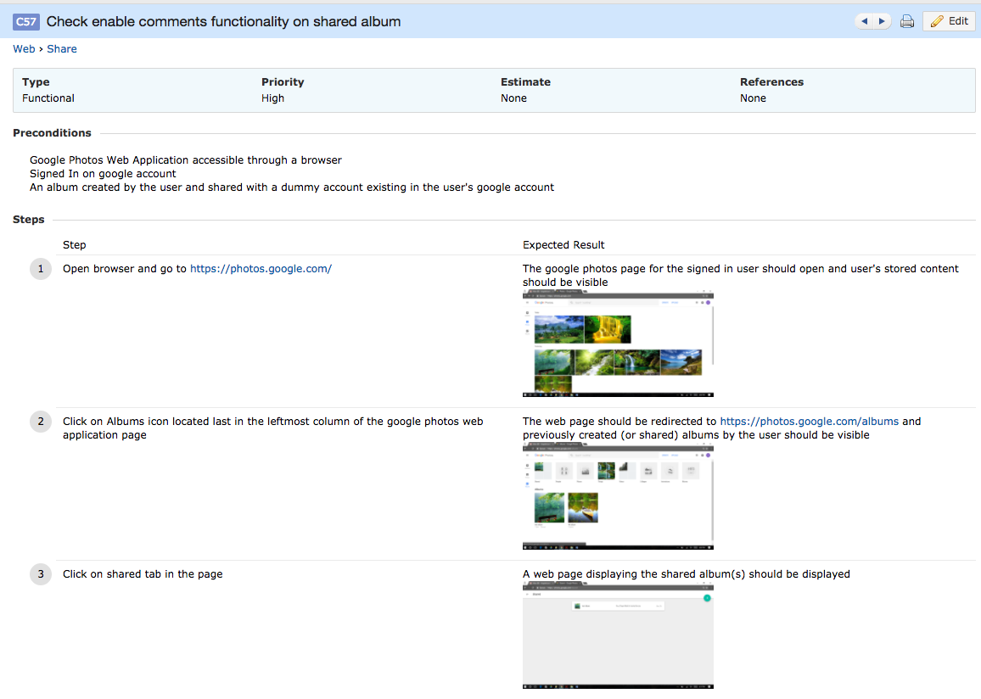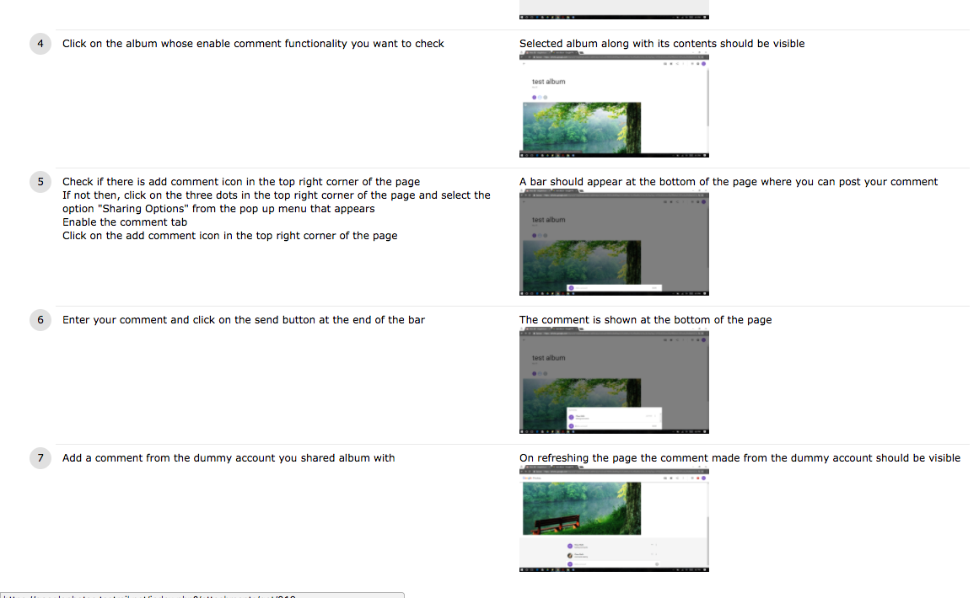

**Test Case #3:** Testing Sharing when Contact input is not valid.

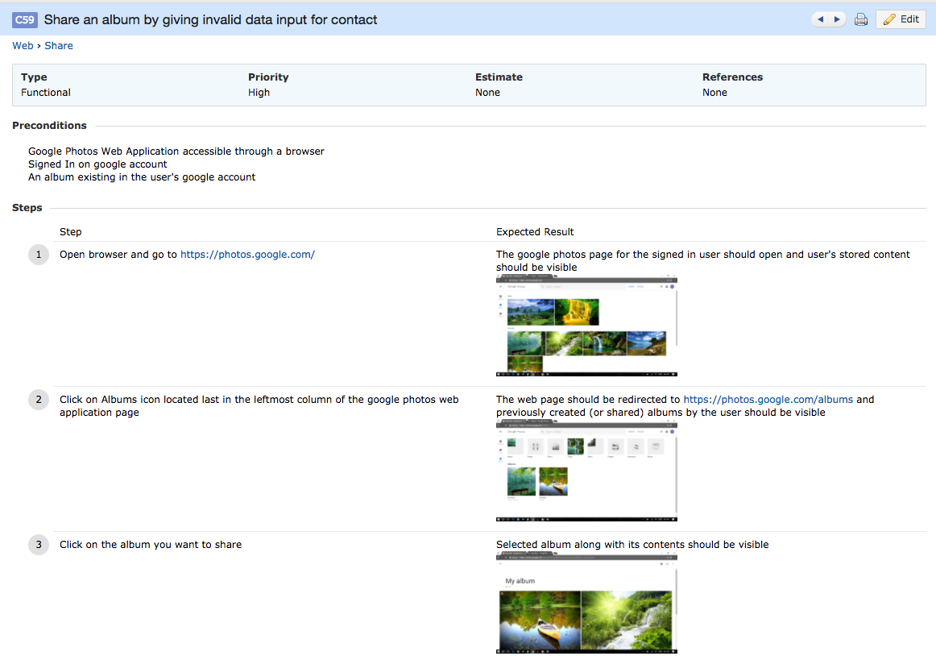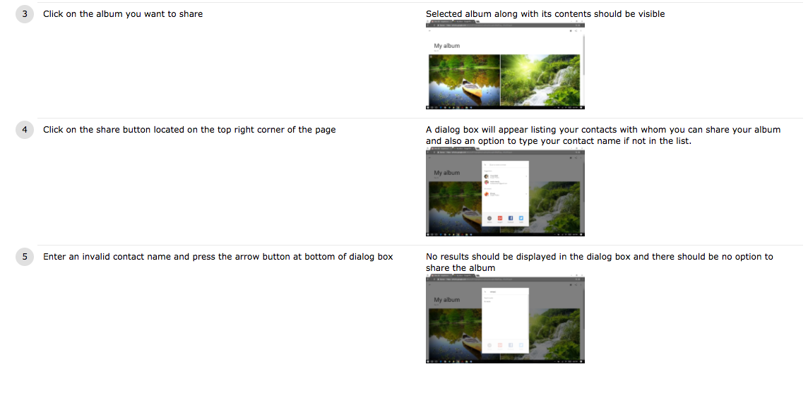

**Test Case #4:** Testing Album changes visible to collaborators.

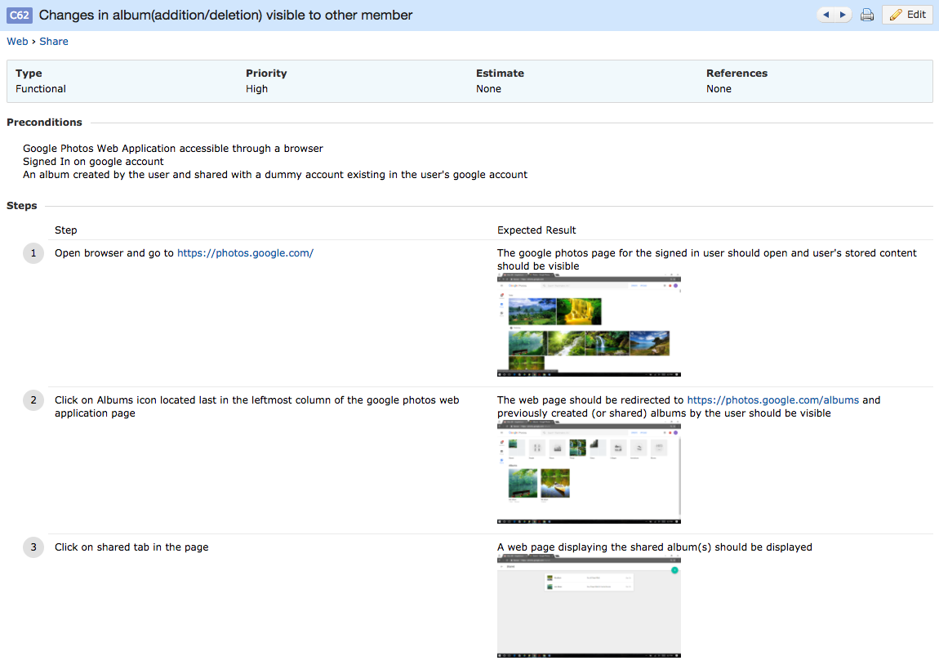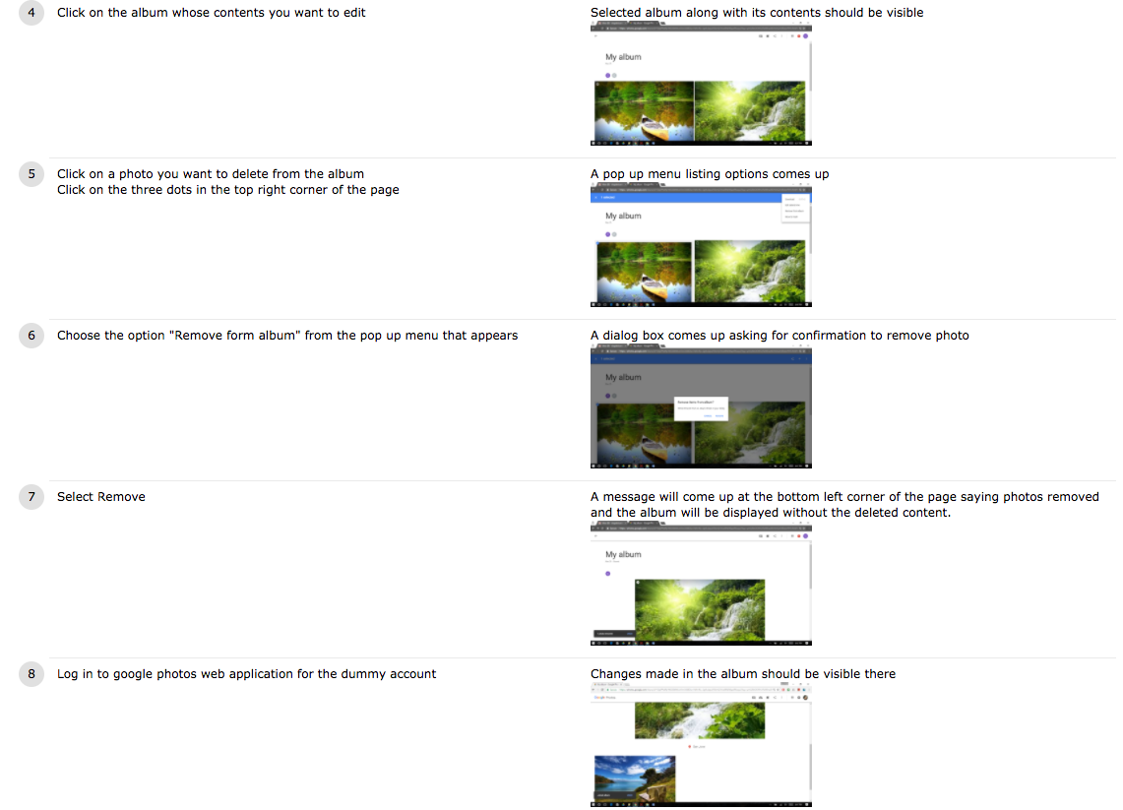

**Test Case #5:** Testing Deletion of Shared Album.

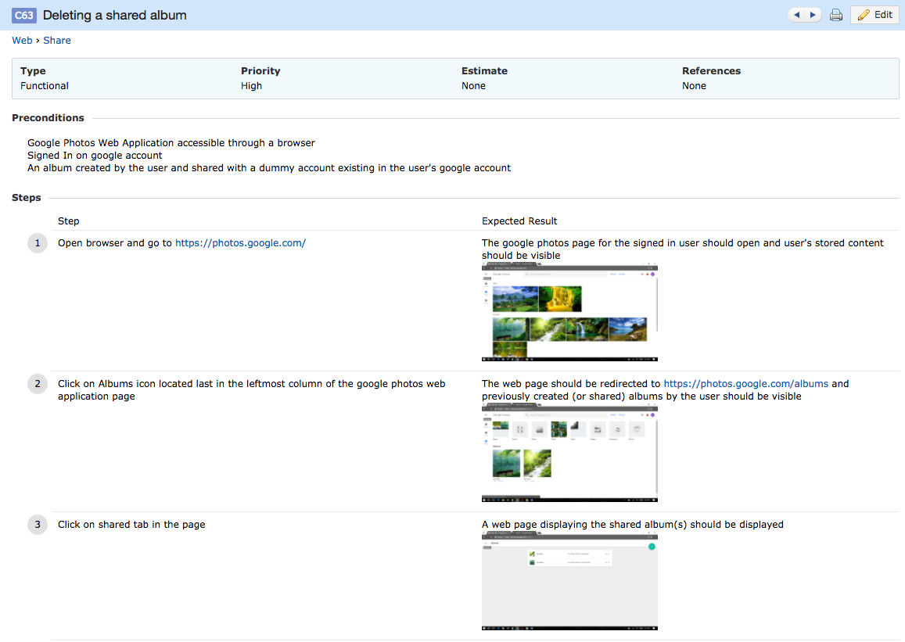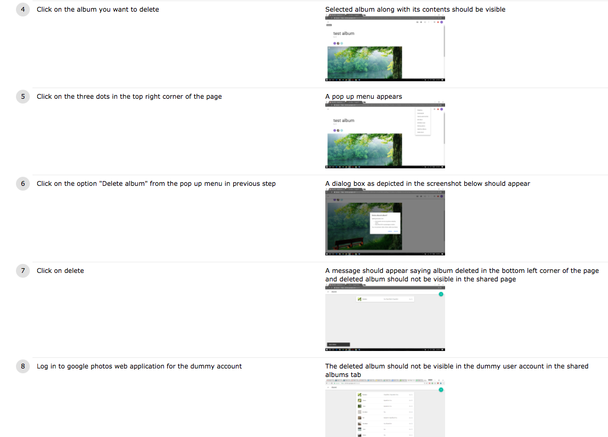

**Test Case #6:** Testing Commenting on new Shared Album.

